Elastic Search – Hello World

Step 1: Setup elastic search development machine

1. Download elastic search from <https://www.elastic.co/downloads>
2. Extract file in your drive
3. Go to bin folder and run elasticsearch.bat as administrator
4. Open the browser and ensure localhost:9200 url is responding

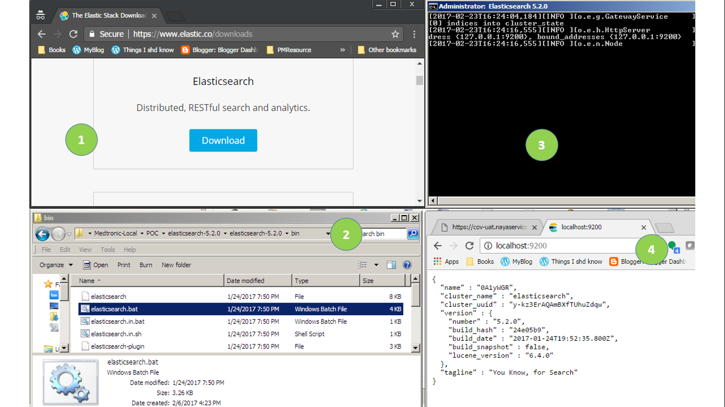

Step 2: Install a web front end for an elastic search cluster <http://mobz.github.io/elasticsearch-head/>

Step 3: Install Allow-Control-Allow-Origin – to avoid cross origin error

<https://chrome.google.com/webstore/detail/allow-control-allow-origi/nlfbmbojpeacfghkpbjhddihlkkiljbi?utm_source=chrome-app-launcher-info-dialog>

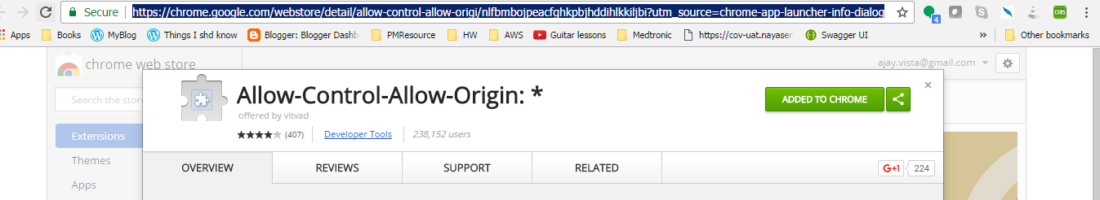

Open elastic search head-master url in browser and ensure head master project connecting with elastic 9200 port(as shown below)

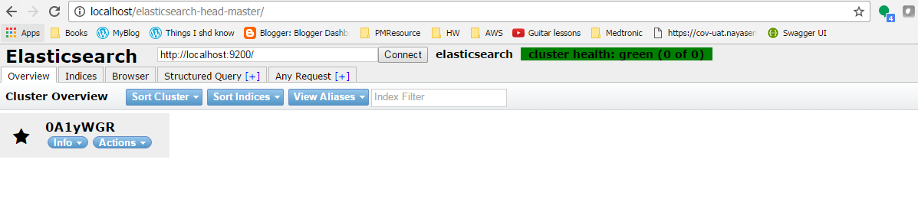

Step 4: Add ElasticSearch.Net into visual studio project using NuGet package manager

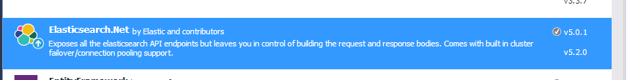

Step 5: How to add and query on elastic

